Black Dots, Caterpillars and Frank
MAT Conference - Launceston
Using Picture Books in Mathematics Lessons.
Workshop by Circular Head Federation
5/12/2012

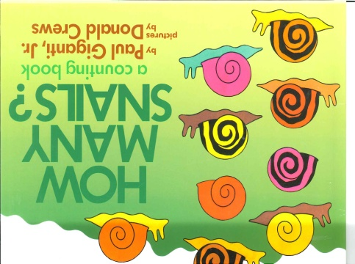
Why use picture books?
- Tuning in (invites children into the world of maths)
- Motivates children to think mathematically (Problem solving, reasoning)
- Teaching children maths concepts and skills
- Plenary – to review explicit teaching
- Connect mathematical ideas to personal experience
- Caters for different learning styles
- Students for whom math is their first love learn to look at books in a new way; Students who love to read are helped to experience the wonder of mathematics in the same way they already enjoy the wonder of books
- For teachers not comfortable in teaching maths this approach builds on strength for teaching literacy and then helps build confidence and enthusiasm
When selecting books it is important that the mathematical focus for the book is clearly explained to the children. These questions also need to be asked:
Questions to help guide your selection of books to use within maths classes:
- Does the book present content that is mathematically sound and appropriate for the level of your students?
- Does the book provide opportunities to introduce or reinforce mathematical symbols and vocabulary?
- Is the book effective for supporting students to think and reason mathematically?
- Will the book help build students' appreciation of both mathematics and literature?
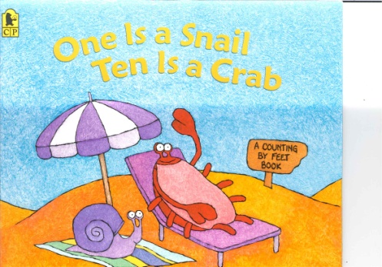
(http://nzmaths.co.nz/picture-books-mathematical-content)

Three tiers of picture books for maths teaching and learning:
Fundamental – story written with the math concept as the driving force
Embedded – story written with apparent math connections, but story stands on its own
Connected – story written with no maths in mind, yet maths can be created on text
Ways to use picture books in the maths classroom
- To provide content for mathematical activity
- To inspire creativity in maths experiences
- To pose an interesting question/problem
- To prepare for, develop or review a maths concept or skill

How does using Picture Books fit into the Curriculum?
Early Years Framework
Outcome 5 Children are effective communicators- Children engage with a range of texts and gain meaning from these texts; begin to understand key numeracy concepts and processes; engage children in discussions about symbol systems, for example, letters, numbers, time, money and musical notation
Australian Curriculum
using picture books will mainly provide opportunities to tune in to content strands. They can be used to reinforce explicit teaching of maths skills and concepts. Picture books are excellent tools for developing the proficiencies (the how) which underpin the content strands. They can help reinforce understanding, problem solving and reasoning.

Resources and References
http://christchurchcitylibraries.com/learning/mathsinpictures/
http://sci.tamucc.edu/~eyoung/literature.html (list of books according to area of maths)
http://www.merga.net.au/documents/MERGA33_Marston.pdf (article about selecting picture books for maths)
http://nzmaths.co.nz/picture-books-mathematical-content (New page on the NZ Maths site that provides picture books for specific content strands)
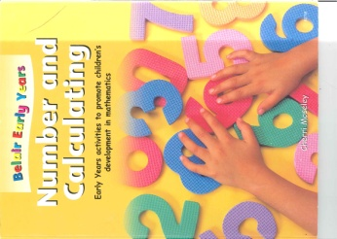
References:
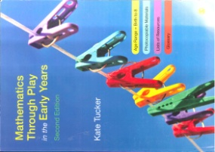
Number and Calculating, Cherri Moseley, Belair Publication
Mathematics Through Play in the Early Years 2nd Edition, Kate Tucker
Books You Can Count On, Rachel Griffiths and Margaret Clyne
The Fun and Creative Maths Classroom, Nicola Baxter, RIC Publications

